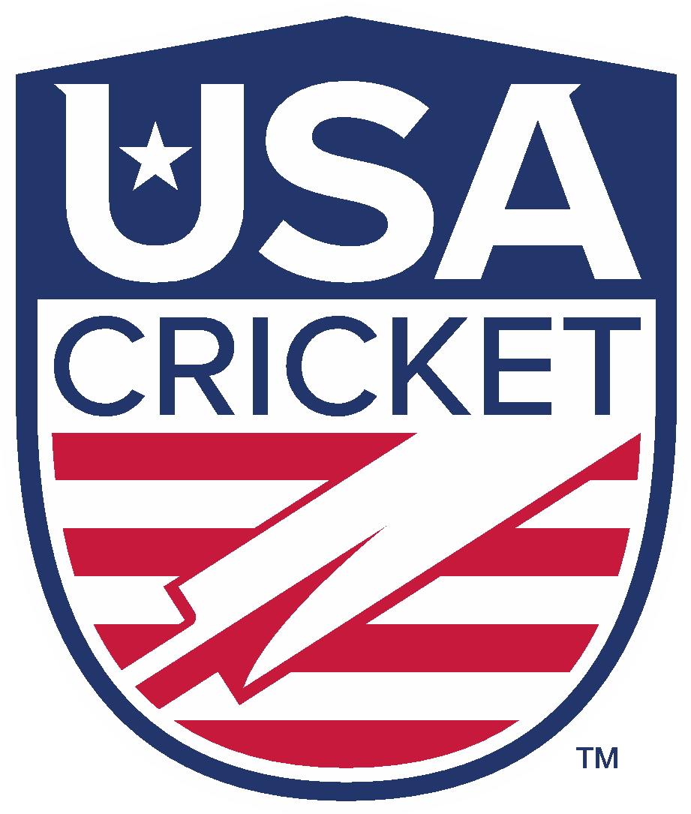
USA Cricket Individual Board Director Application
USA Cricket was established in 2017 to act as the national governing body for the sport of cricket in the United States, and is recognized as an Associate Member of the International Cricket Council. It is a 501(c)(3) charitable nonprofit organization incorporated under the laws of the state of Colorado, but is now headquartered in the San Francisco Bay Area, California. Its mission is to govern, regulate, develop and promote the sport of cricket (including hardball, softball, disabled and all other types of cricket) at all levels in the United States, and to enable United States cricketers to successfully compete in national and international competition.
The purpose of this application is to identify those individuals interested in applying for the one (1) open Individual Director seat on the Board of Directors that will be elected per the USA Cricket Constitution.
Applicants interested in serving as a candidate should first read and understand the expectations of Board membership and the Board job description, and read and understand the Constitution, and submit a completed application by 11.59pm PT, March 19th, 2021. Additional information regarding the requirements for the eligibility of these roles can be found in Section 7 of the Constitution.
All completed applications or questions about the process should be sent by email to ngc@usacricket.org.
USA Cricket Board of Director Expectations:
- Support the mission of USA Cricket.
- Work as a part of a cohesive team seeking to accomplish common goals.
- Dedicate time to USA Cricket and USA Cricket Board meetings including attending Board meetings.
- Respect and support the majority decisions of the Board.
- Participate actively in Board meetings while sharing his/her skills, expertise and experiences to support USA Cricket.
- Represent all those whom USA Cricket serves and not a particular geographic area or constituent group.
- Declare conflicts of interest as they pertain to your position on the Board and abstain from voting when appropriate.
- Do your best to ensure that USA Cricket is well-maintained, financially secure, growing and always operating in the best interest of cricket in the United States.
- Fulfill Board responsibilities while complying with the duties of care, loyalty and obedience.
If you are accepted as a USA Cricket Board member, you will be required to obtain and submit records of a full criminal background check.

- Position applying for (please select only one):
Individual Director

- Candidate Name:

Mailing Address:

Cell Phone:

Email Address:
- Employment:

Current Position:

Current Employer:
In addition to filling in the above, please attach a current resume.

- Please list boards and committees that you serve on, or have served on, with applicable dates (business, civic, community, political, professional, recreational, religious, social, etc.)

- What other volunteer commitments do you currently have?

- Why are you interested in serving as a Board member for USA Cricket?

- How do you feel USA Cricket would benefit from your involvement on the Board?

- Please share any other information you feel important for consideration of your application to serve as a USA Cricket Board member:

- Please review and respond to the following questions. Use a separate sheet as necessary.

- Are you aware of any information about yourself, which might tend to reflect unfavorably on your reputation, morals, character or ability as a board member for USA Cricket?

Yes No If yes and would like to explain, use a separate sheet of paper.

- Have you ever been convicted of a felony?
Yes No If yes and would like to explain, use a separate sheet of paper.

- Have you ever been convicted of a controlled substance offense?

Yes No If yes and would like to explain, use a separate sheet of paper.

- Have you ever been convicted of a sex-related crime?
Yes No If yes and would like to explain, use a separate sheet of paper.

By signing below, I attest that the information I have provided is true and correct. Additionally, my signature represents my agreement to the following statements:

- I understand and agree to the USA Cricket Board of Directors Expectations;

- I agree to participate pursuant to the Policies, Procedures and Constitution of USA Cricket; and

- I am willing to complete a background check as part of the application process.

- I have read the USA Cricket Code of Ethics and can confirm that either:

  - I have no potential conflict (actual or perceived) thing to declare

  - I am aware of the following potential conflict (actual or perceived):

Signature:

Date:
Each of the individuals running for election for the Individual Director seat is eligible to submit a one-page candidate statement that will be included with the election ballot. The candidate statement can include pictures and/or narrative and will be due shortly after the candidates have been reviewed and confirmed by the NGC.

